A Graduation Message
Graduation is a
Time to remember
And a time to dream,

A time to look back
And a time to reach forward,

A time for songs of laughter
And a time for tears of joy.

A time for letting to
And a time for discovering
Hopes and dreams that are yet unborn,

A time to say good-bye to yesterday
And a time to greet tomorrow
With courage,

A time for loving hearts to gather
And a time to celebrate all that you are…

And all that you may become.

Retrieved By: The Newspaper Club (Pintrest)

Congratulations Golden Ring School 8th Grade Students!!!!

Mental Health

May is mental health awareness month. Our mental health is our social well-being. Our mental health can determine how we act, feel, think, and handle stress. To maintain our mental health, we all just need to take a break, keep active, or ask for help! Stress can block hormones and you might not even know it! You should also try and take a break from social media, while seeing other’s accomplishments it might make you feel disappointed at where you are. Remember our mental health is just as important as our physical health.

This Photo by Unknown Author is licensed under CC BY-SA-NC

Word Scrambles
Word Bank:
H l m e l n a h t e

_ _ _ _ _ _ _ _ _ _ _ _

Word Bank:
I p i o s r a n t t m

_ _ _ _ _ _ _ _ _ _ _

Answer 1: Mental health Answer 2: Is important

By Bidemi Ogunjinmi

This Photo by Unknown Author is licensed under CC BY-SA

Riddles
- What goes up and never comes down?

- What’s full of holes and can easily hold water?

- What's a question you can never answer yes to?

- David's father has three sons: Snap, Crackle, and….?

- The more you take, the more you leave behind. What am I?

- What has a head, a tail, is brown, and has no legs?

- You live in a one-story house made entirely of redwood. What color would the stairs be?

- What runs around the whole yard without moving?

Answer key. 1. Age…, 2. A sponge, 3. “Are you asleep?” 4. David, 5. Footsteps, 6. Penny 7. What stairs?, 8. fence here are no stairs.

By Bidemi Ogunjinmi

This Photo by Unknown Author is licensed under CC BY-SA
Graphing
Careers
Doctor
Lawyer
Auto Mechanic
Teacher
Scientists
Engineer
Pilot
Veterinarian
Key: each box = 5 people
Graph Questions
How many people voted for their favorite career? ____
How many people want to be an engineer? _____
How many people want to be a doctor? _____
How many people want to be a scientists or veterinarian? ____
Name the careers that 2 people voted for? ____________________________________________________
How many more people want to be an engineer than an auto mechanic? _____
By The Newspaper Club

This Photo by Unknown Author is licensed under CC BY-NC-ND
Recipes
Cool Summer Treat
Lemon and Peppermint Straw
Ingredients:
1 fresh lemon
1 thick peppermint stick
Directions:
Push the peppermint stick into the lemon. Squeeze the lemon and sip the juice. Enjoy!!!
By The Newspaper Club
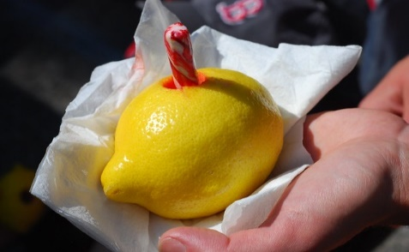
This Photo by Unknown Author is licensed under CC BY-NC-ND

