A Few Tips to Staying Safe At School
A few tips to staying safe in school during hybrid learning.
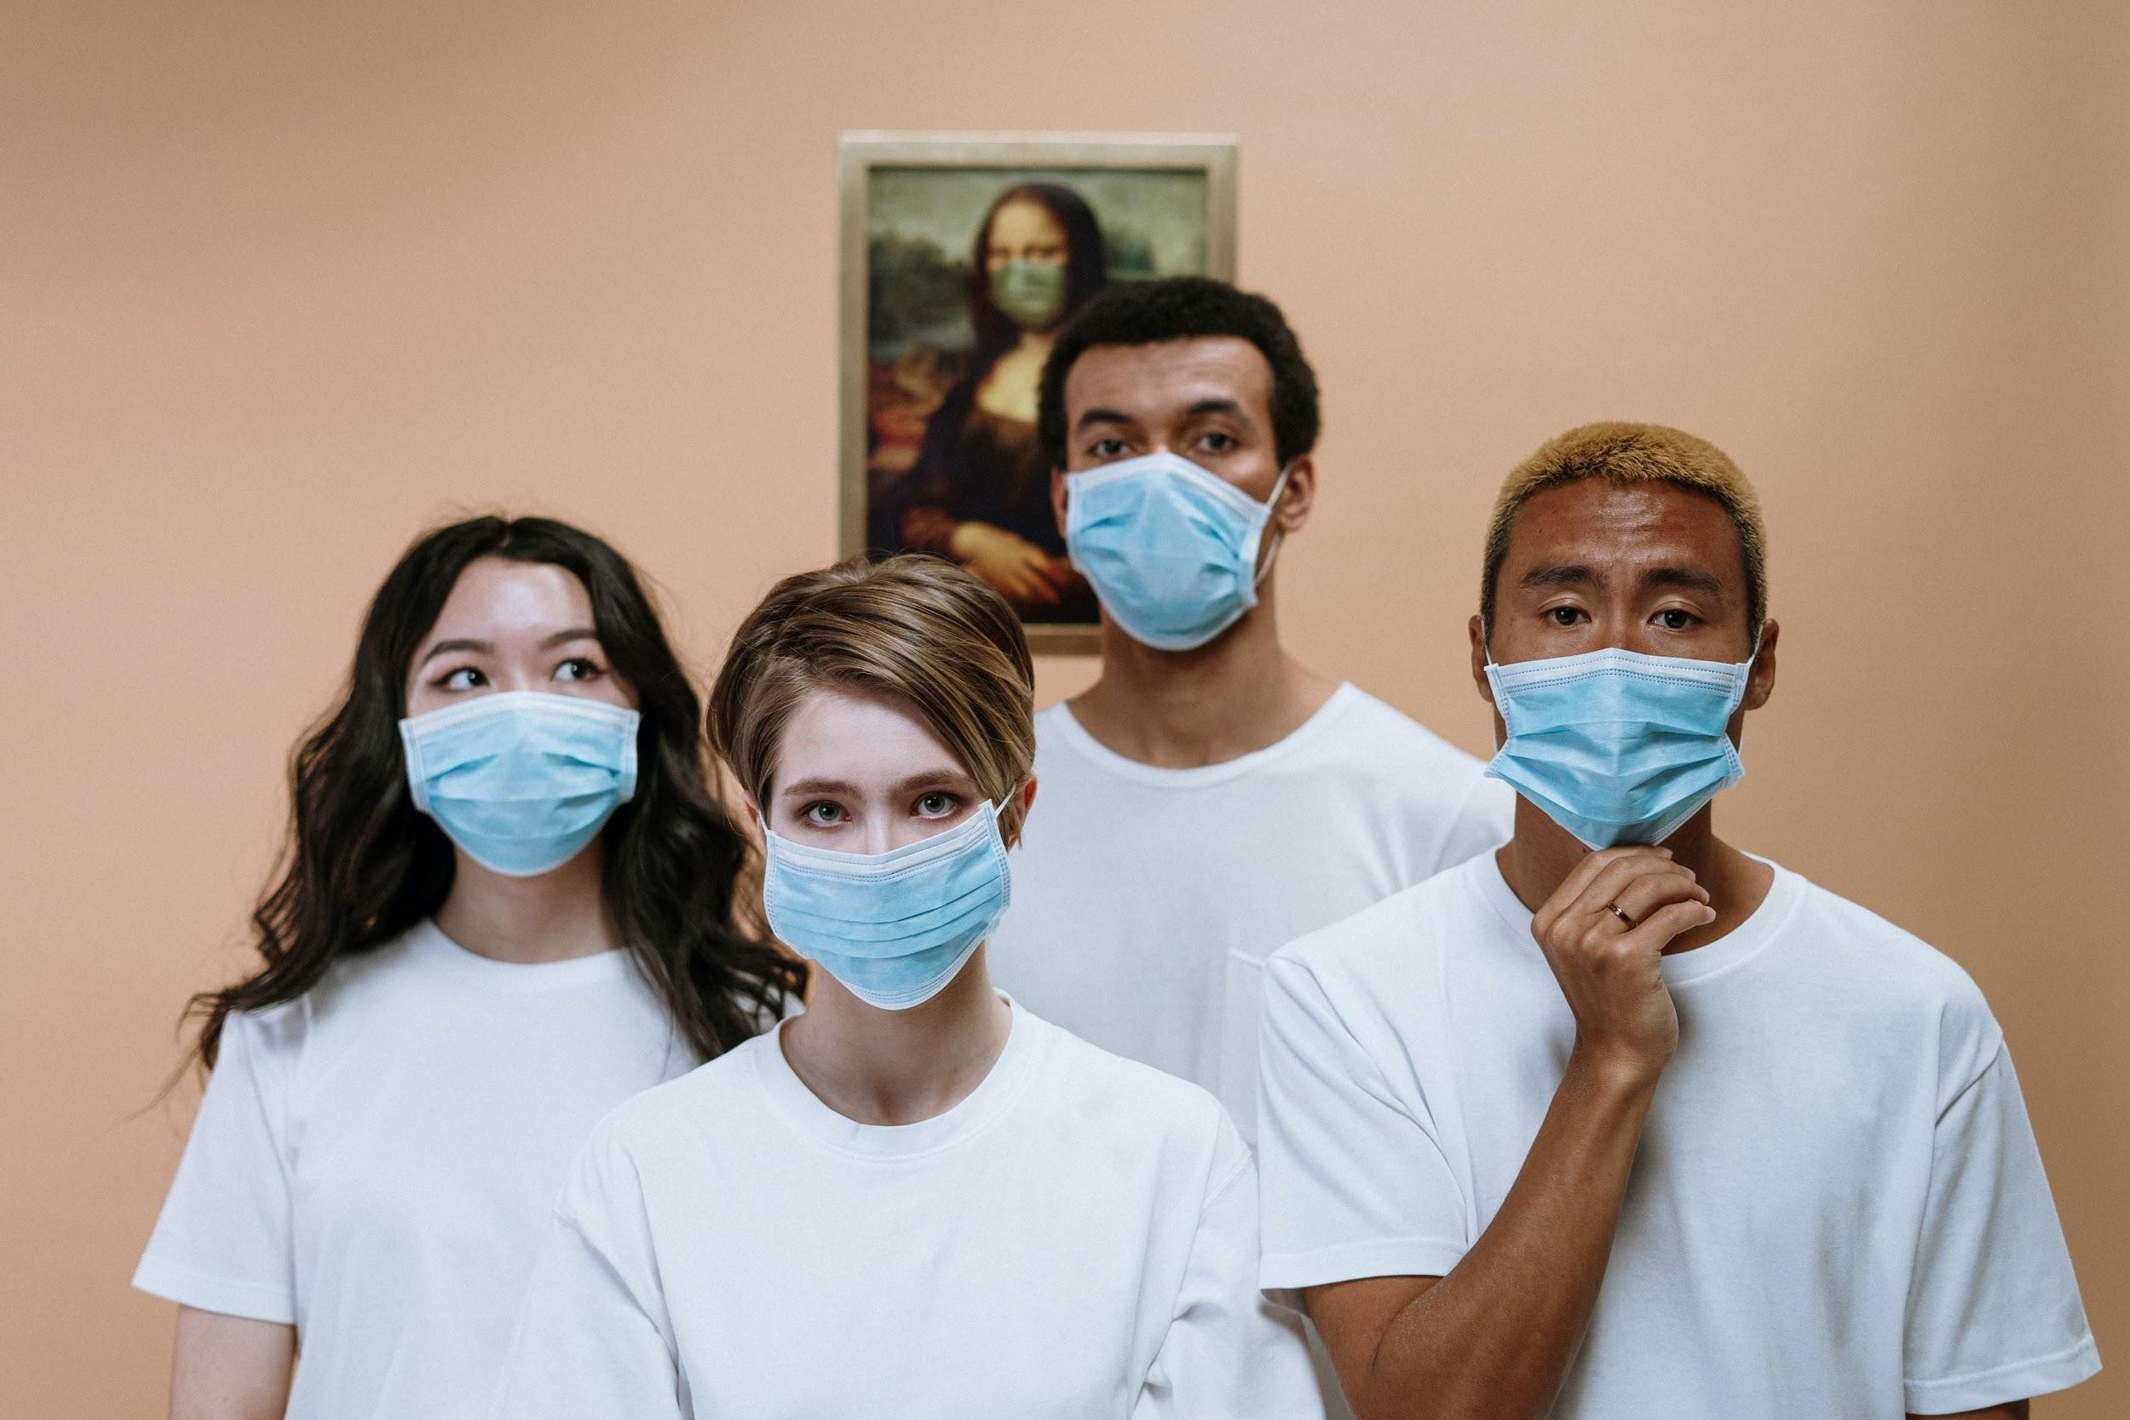
The most basic thing anyone could do to stay safe. WEAR A MASK! A mask will protect you from the virus. The N95 mask offers more protection than a medical doctor’s mask.
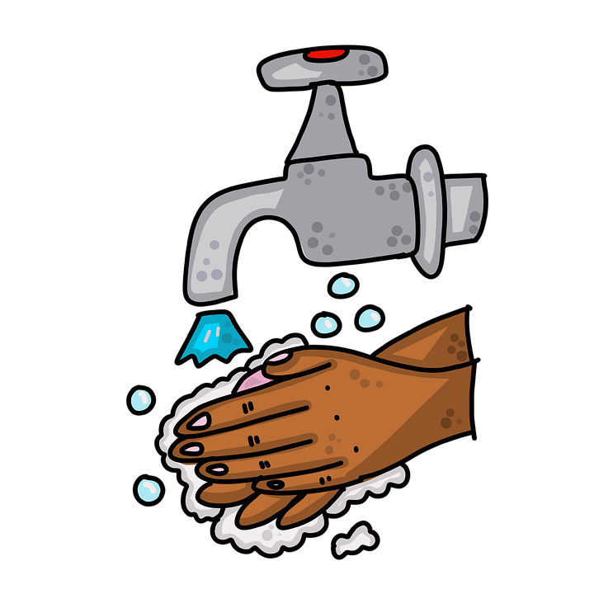
You should also wash your hands or use sanitizer after every activity in school. So that your hands are clean. Don’t touch your face!!
Stay three to six feet apart from others to prevent the spread of Coronavirus. If you want to be safer; then, you can stay twelve feet apart from each other.
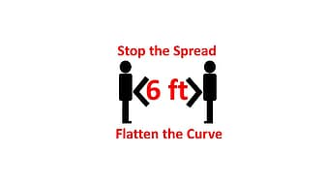
Listen to your teacher’s instructions so that you are safe and are in the right place at the right time.
If you feel sick or are sick, then you should stay at home to prevent the spread. You can always do virtual classes if you cannot make it to school. You should also stay at home if you’ve come in contact with someone who is diagnosed with Coronavirus. Please follow these tips in order to stay safe in hybrid school!!! :D
By: Barack

Covid 19
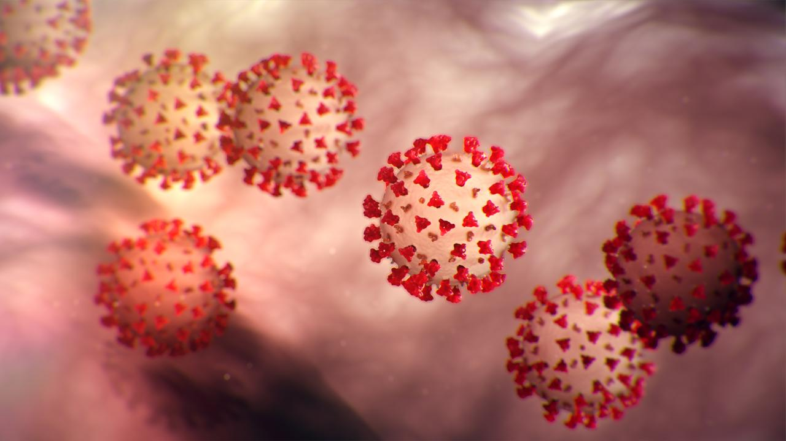
As we all know we have been in quarantine for a year and the vaccine has been out to the public.
COVID-19 has changed so much in the world and the big question is, will we EVER be without a mask again?? Well, there is no answer yet but kids in Baltimore County are returning to school!! Kids will be having to wear masks at school all day. I think maybe one day we will be without a mask; but it will take a long time for that to happen.
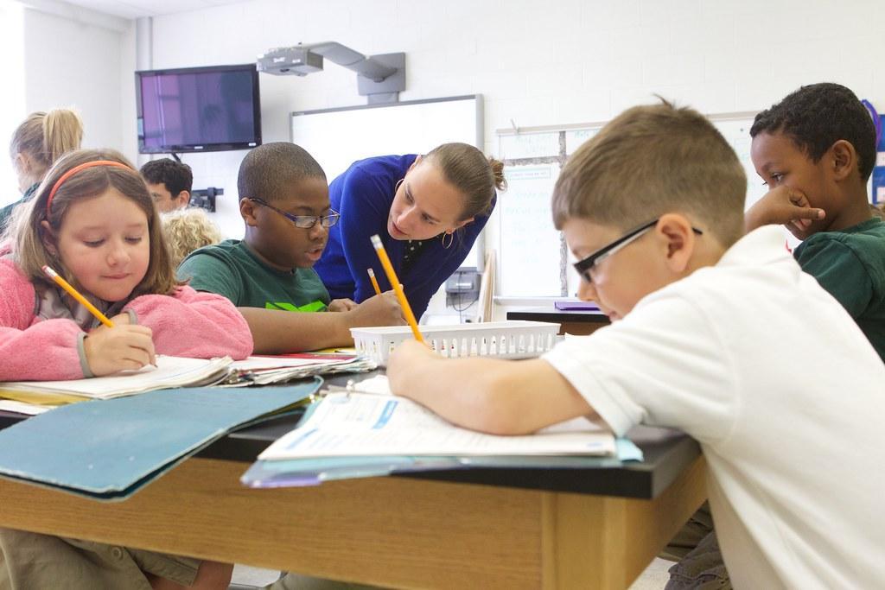
So, our former president (Donald Trump) was on a Fox News interview and he said, “I would recommend it (the vaccine), and I would recommend it to a lot of people that don’t want to get it, and a lot of those people voted for me, frankly.”
Over 147 Thousand People have gotten the COVID-19 Vaccine and that's only in Maryland so imagine the whole U.S.A or even the whole world.
So, the reason for this article is to get vaccinated and just wear the mask; because, if you do you could save a life.

By Audrey
Elementary To Middle
Working Hard
We’re so excited to go from elementary school to middle school!! But what we don't notice is that it gets harder. Everything changes such as grades, schedules, and even classes. When we were in elementary school, grades in the future for college or high school didn't really apply. Grades in elementary school just prepare you for middle school because people know that it's only getting harder.
Some of those examples are grades. You know that when you get to another grade that everything gets harder. Middle school teachers take it up a notch to see how you're growing through that school year. Grades are very important. Grades from middle school and on will predict if you get a scholarship to college. But not everybody wants to go to college.
More examples of how school is just going to get harder are classes. Classes have different subjects. This means you're balancing all of your classes. That also means you should work hard in every class, to get better grades. Working hard in class as a kid can also be helpful in the future. If the employer sees the employee working hard, that could lead to a promotion or even a better job.
Work hard in school! Even trying would help. If you try your hardest and put everything you learned into something; that would help you get a good grade or even a good job.
By Adreonna
Top Songs
Hello Golden Ring!!! The top 3 songs in the pop genre are 34+35 remixes with Ariana Grande featuring artists such as Doja Cat, and Megan The Stallion. YOU GO GIRLS!!! Glass Animals “Heat Waves” hit the chart at number 2. And finally, the very well-known Dua Lipa featuring DaBaby with “Levitating.”
The top 3 songs in rock and roll/pop are Machine Gun Kelly “my ex’s best friend” featuring artist Blackbear. Another very well-known grunge band we all love, Nirvana with their hit “Smells like teen spirit” hit the rock charts as of 1991 for Alternative/ Indie Rock. The final song was a TikTok hit which is artist Masked Wolf with “Astronaut in the ocean.”
The 3 top songs in Hip-Hop and R&B are Cardi B with her new most recent song “Up” which hit charts at the #1 song. The #2 on the charts was legend Juice WRLD and Young Thug “Bad Boy” as did the video too.
By: Savannah
Riddles
Can you name five consecutive days without using the words Monday, Tuesday, Wednesday, Thursday, Friday, Saturday, or Sunday?

How can you take 2 from 5 and leave 4?

You live in a one-story house made entirely of redwood. What color would the stairs be?

Answer key. 1. yesterday, today, tomorrow, the day before yesterday, and the day after tomorrow, 2. F I V E remove the f and the e and you’ll be left with IV the roman numerals for 4 :D, 3. There are no stairs. You live in a one-story house.
By: Williams

